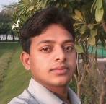
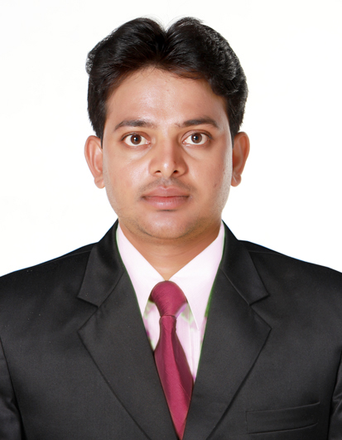
CURRICULAM-VITAE

SOHAN KUMAR PAL
House no. 97 Village- Chhata, Post- Chhata,
dist.- Ballia, U.P,Pin code. 277210
Mobile: - 9876461891,Passport No. M5438099
Email-Sohanpal991@gmail.com

CAREER OBJECTIVE:-
Looking for a challenging career in a premier & fast growing organization, where I can develop new knowledge & sharpen my skills and put my best efforts to hold a position of responsibility and workout something better for achieving organizational & individual goal.
work experience:- ( 05 yrs )
Presently Working with Sterling & Wilson ltd. Sweihan, Emirates of Abu Dhabi. Project 1177 MWp as a Electrical Engineer From 07 July 2018 to Till date.
Workd with ACME Cleantech solution Pvt. Ltd in Rewa Ultra Mega Solar (RUMS) Pariyojna unit no.2# 250MW project as an Electrical Engineer from July 2017 to till date.
Workd with ACME Cleantech Solution pvt ltd Gurgaon as an Electrical Supervisor in Operation and Maintenance from 2013 to 2015.

Worked with Rock man Industries Ltd, Ludhiana (Punjab) as an Electrician in operation and maintenance from 2011 to 2015.

Scope of work (250 MW solar PROJECTS, 220 KV switch yard

Testing and Commissioning

- 100 MVA power Transformer
- CT, PT, Isolators, Breaker (ACB, SF6, VCB, MCB, MCCB etc.)
- Relay & protection Panel.
- Solar PV modules erection , testing & commissioning
- Inverters testing and commissioning
- DG Operation & maintenance
- . Control & power cabling work.
- Utility of building construction for electrical works
- Planning of work and preparation of daily progress report.

Strenth:-
- Positive attitude.
- Hard Working dedicates.
- Good Communication skills.
- Result Oriented, confident

Educational Qualification:-

Examination | Discipline/  Specialization | School/College |  | Board/ University | Year of passing | %
TECHNICAL
Polytechnic | Electrical Engineering | Vidhya sagar polytechnic college, Dhuri, Punjab | The P.S.B of Tech. Edu. & Industrial training |  | 2017 | 59.93
ITI | Electrician | State industrial training institute, UP | Ballia  (UP) |  | 2010 | 67.14
ACADEMIC
12th | Math Science | P.D. Inter Collage Gaighat |  | U. P. Board | 2008 | 46.4
10th | All Subject | S.B.R.H.L.High School, Chhata |  | U. P. Board | 2006 | 58.5

PERSONAL PROFILE:-

Fathers Name : Mr. Bhola nath pal
Date of Birth : 10-09-1991
Gender : Male
Nationality : Indian
Language known : Hindi & English
Marital status : Unmarried
Hobbies : Playing cricket, racing, music, Travelling
& Reading Books.

DECLARATION:-

I hereby declare that all the information gives above are true to the best of my knowledge.

Date:-
Place: - (Sohan kumar pal)

